This analysis began with data on 277 ski resorts in 35 states with data on 36 features. Resort data includes physical features and amenities of individual mountains such as chair lift count, vertical drop, etc. State data was included on the states which have ski resorts as well, this includes population, area etc.

Big Mountain resort wants to capitalize on their features and wants to know whether it competitively prices their lift tickets. In order to gain insight into Big Mountain Resort’s situation, a model was constructed to estimate Big Mountain Resort’s ticket price with a market valuation of its features. Currently Big Mountain charges $81 for its adult weekend pass. But the model suggests that Big Mountain can support a ticket price of $96. With ticket sale projections this can equate to an additional 26 million dollars in revenue. This estimate had a mean absolute error of $10, even with this consideration Big Mountain has room to increase their prices. As illustrated below, an increase no more than $15 wouldn’t drastically change Big Mountain resort’s competitiveness in either the Montana market nor nationwide.

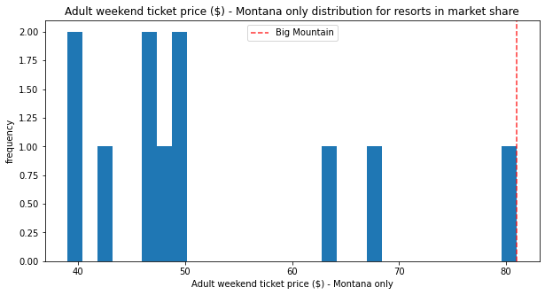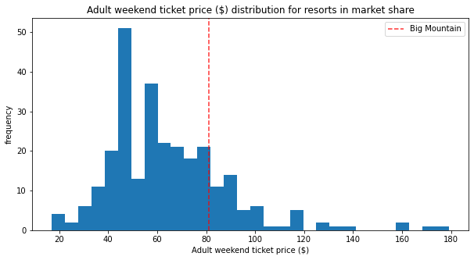

Features that were determined to be important factors in predicting ticket prices were vertical drop, snow making coverage, total chair lifts, number of fast quads, run count, length of the longest run, presence of trams, and total skiable area. From the figures below, it is apparent that Big Mountain is one the high end of the distribution compared to other U.S. resorts.

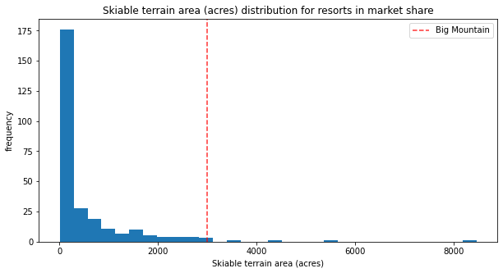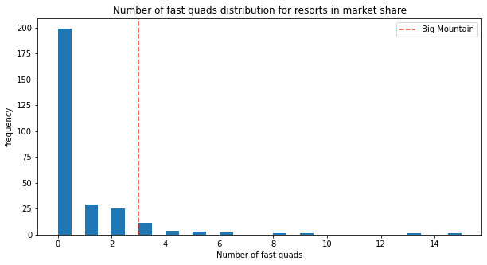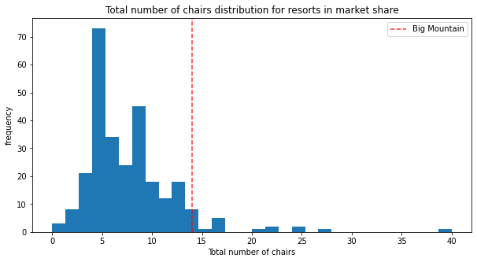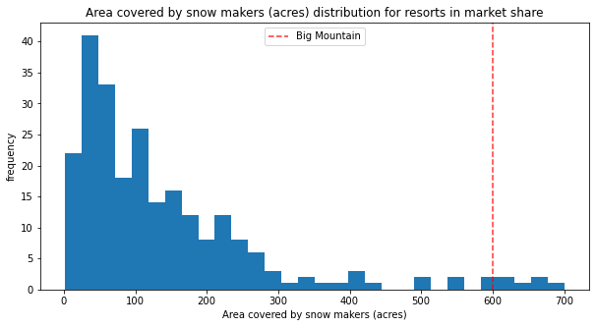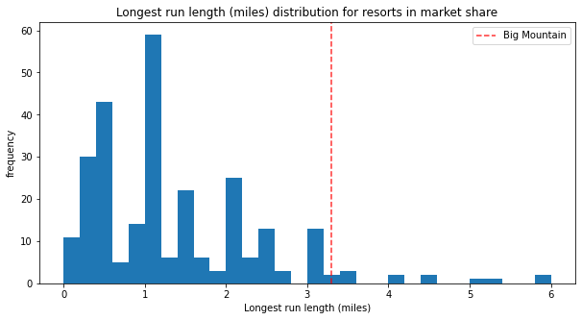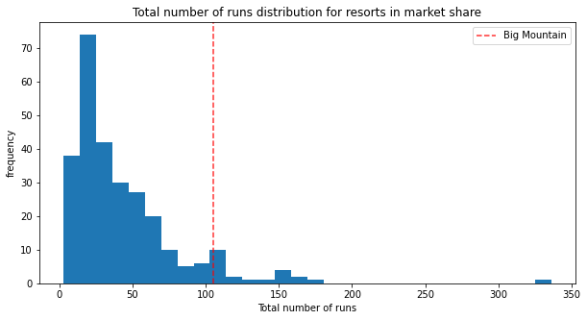

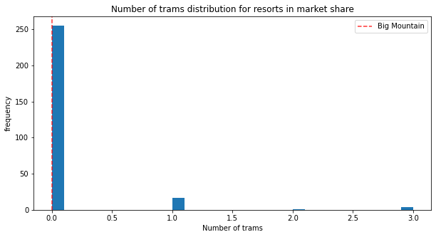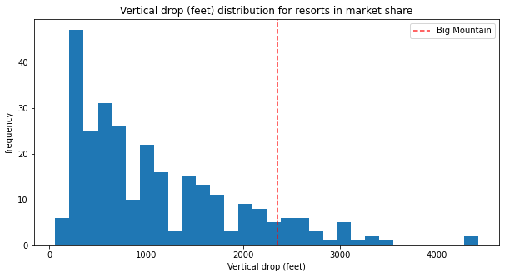

If Big Mountain Resort would like to maintain their current price level, there are options to reduce their operating costs. Big Mountain can close the least used runs to reduce costs. From the figure below, closing one run will have no effect on prices. Closing up to 3 runs is equivalent to closing 5 or 6 runs and would only account for about a .70 loss in ticket price.

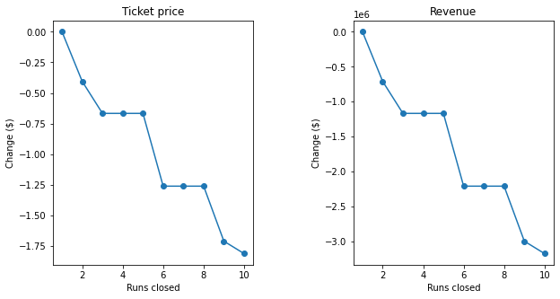

If Big Mountain wanted to increase their ticket price, but use the increased revenue to invest in the resort, we explored the effects of opening a new run that increases the vertical drop and requires a new chair lift. Increasing these features would be associated with an increase in per ticket pricing by about $8.60